What is service ?

Service allows us to expose the pods/deployments to outside, inside of the cluster.

It’s like a load balancer.

Types of clusters:

* Cluster IP – Mostly used in production with ingress controller & ingress and for DBs. Used for internall routing.
* NodePort – Used for Testing application using ephermal ports. Not used in production since it uses ephermal ports.
* Load Balancer – Good in production, but if we have a lot of services we need to create more Load Balancers. Time consuming if we keep load balancer for each service, It increases the cost and problem with service availabilities. So we use ClusterIP along with ingress controller.
* Head Less Service(Mysql, postgres, mongodb, elastic search)
* External Name

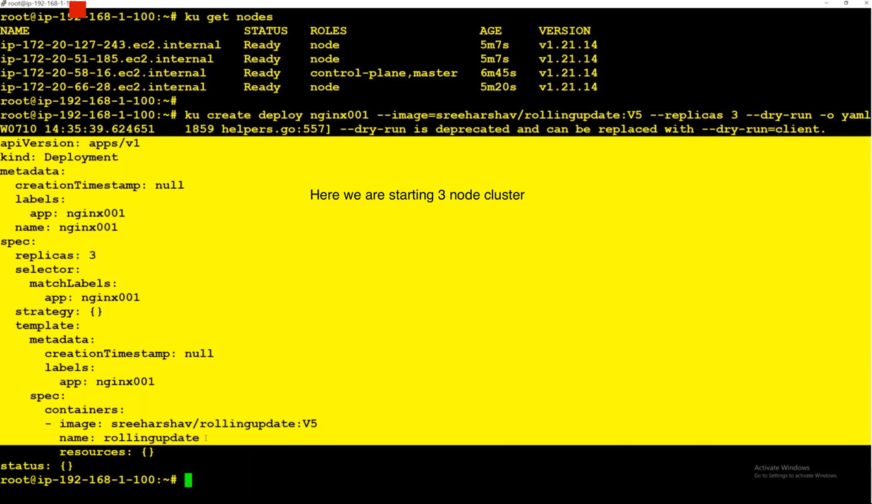

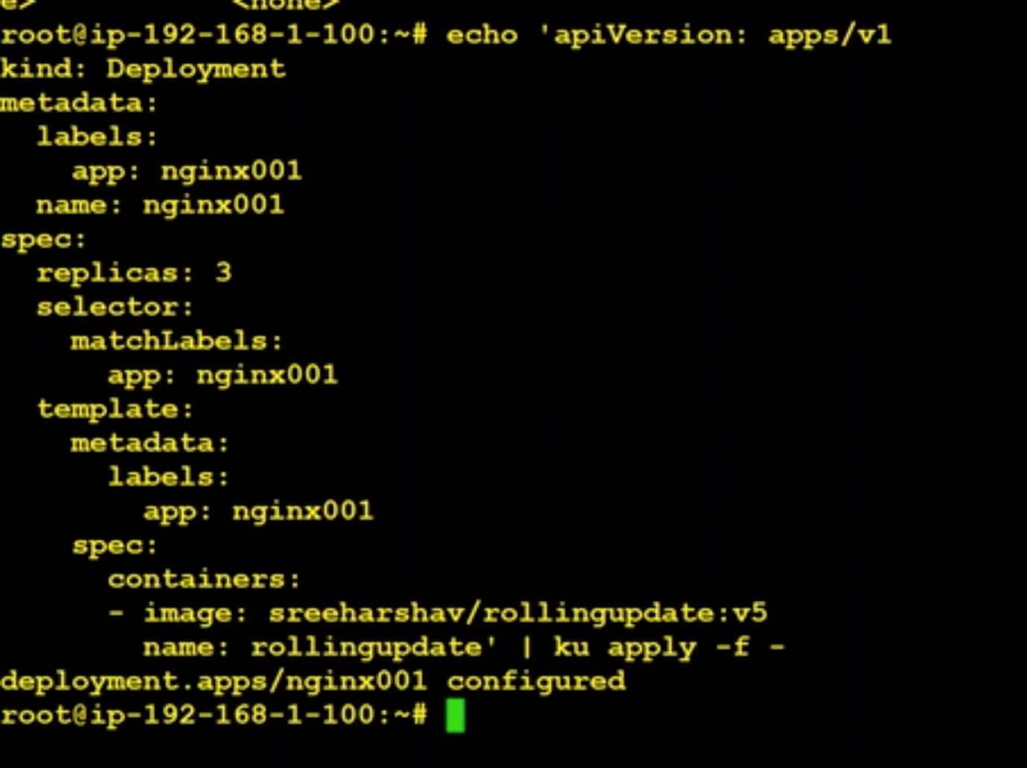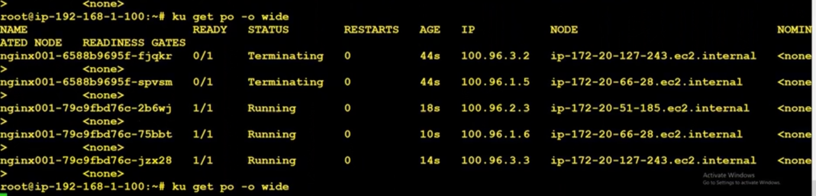

Now application is running inside the pods. How can we connect to this application ?

We can connect to the application using clusterIP. This is used for internal communication.

Internal communication means communication between pods. To test this we can create another pod and try access application running.

Here we are connecting to the application internally using three different ips. But we should connect to only one ip. And that ip should distribute the traffic.

Here Internally we can connect to the deployment and that should internally distribute the traffic. For that we need to expose the deployment like below.

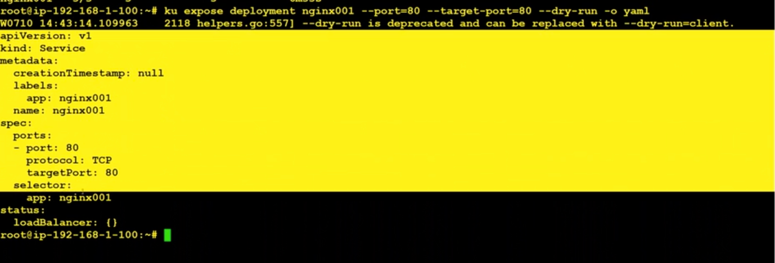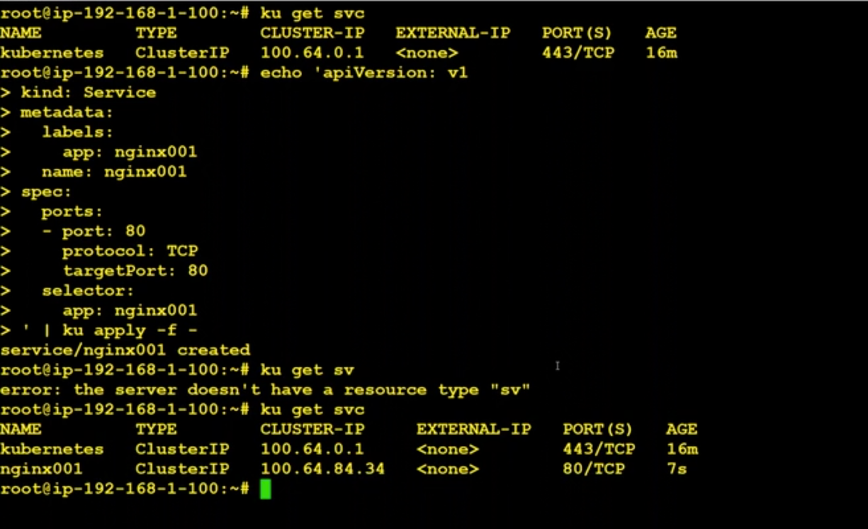

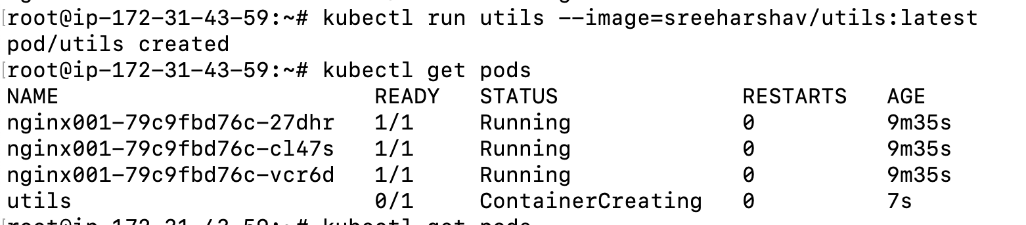

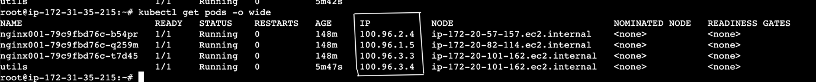

After exposing we no need to give ips while doing curl, we can give deployment name and that will distribute the load in between.

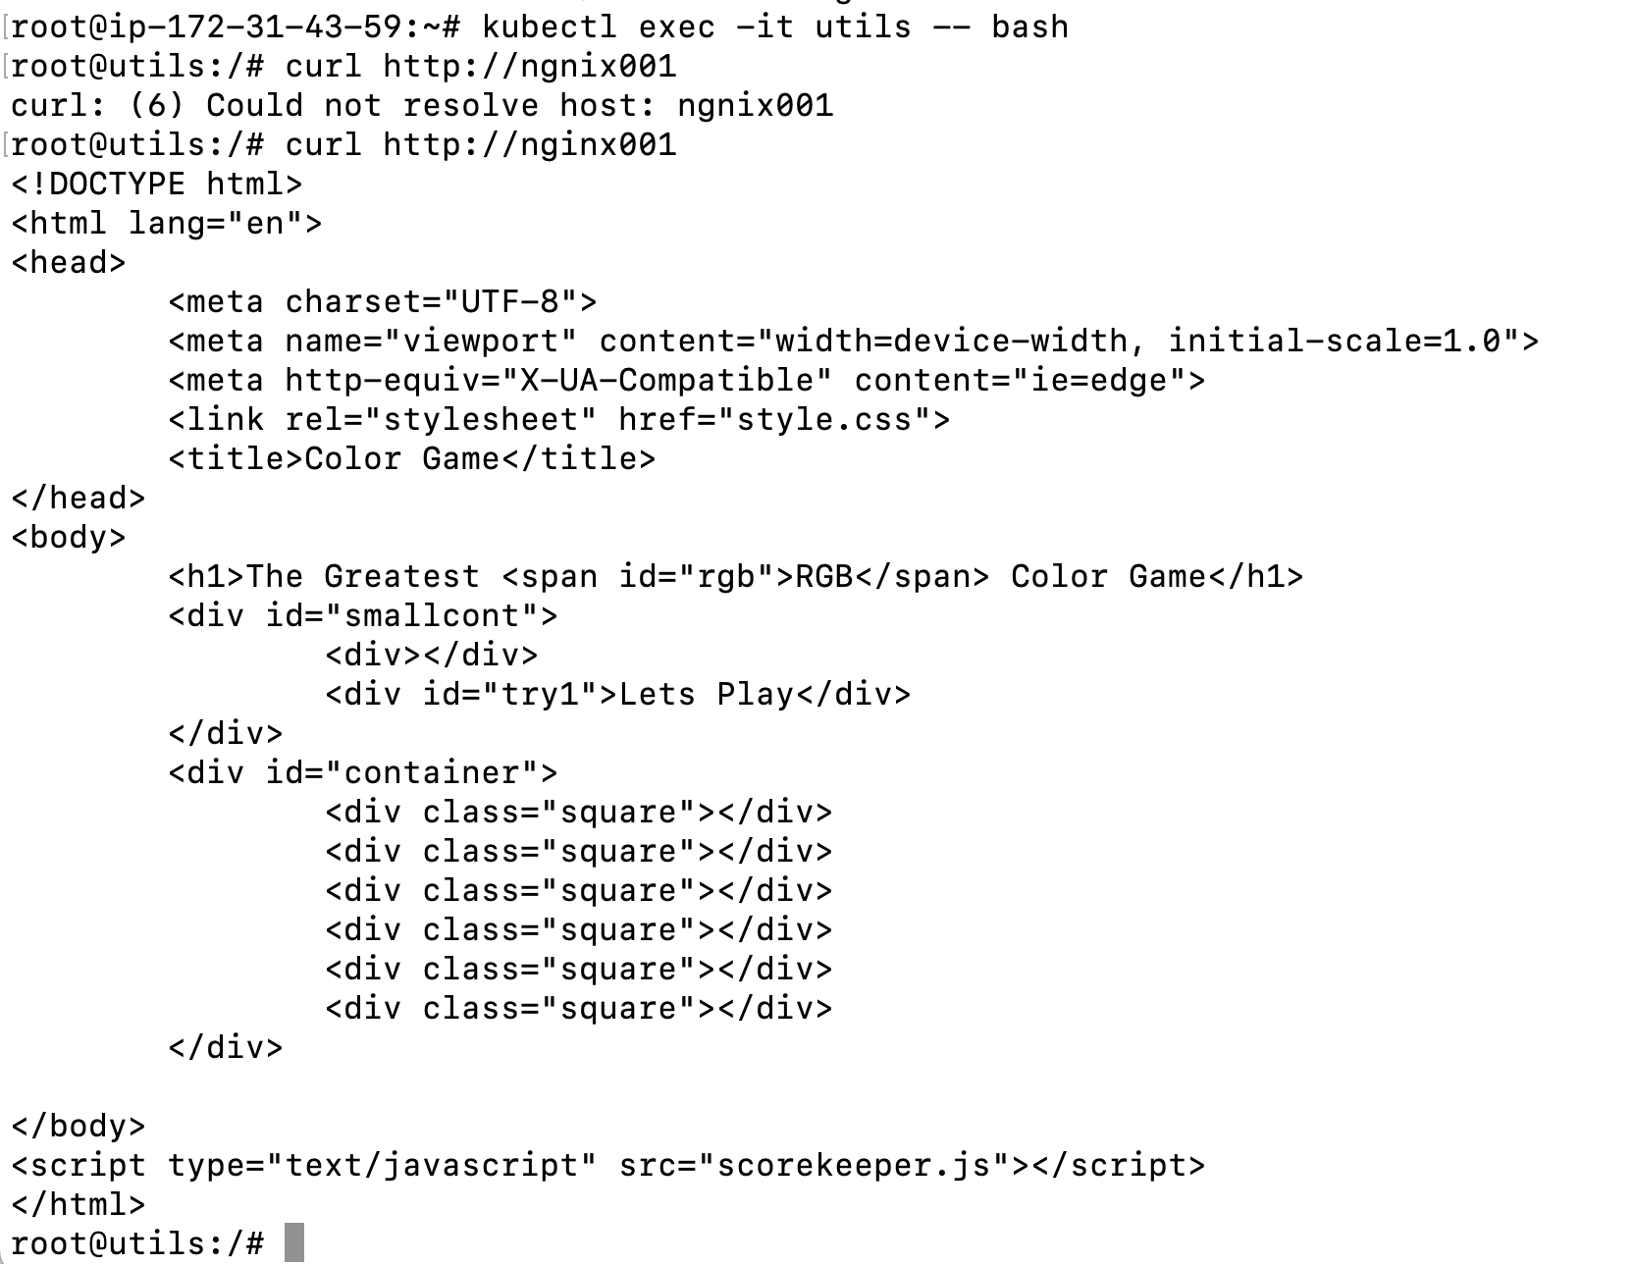

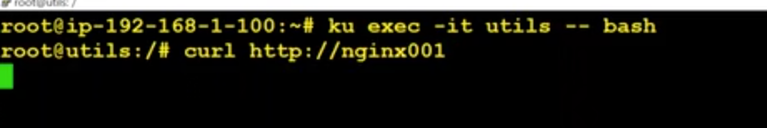

**How to edit deployment ?**

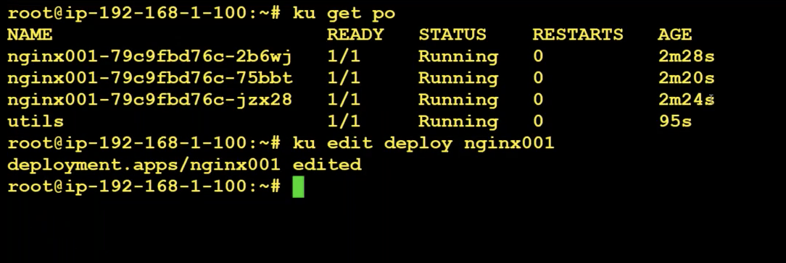

Then change the rollingupdate:v5 to testcontainer:v1

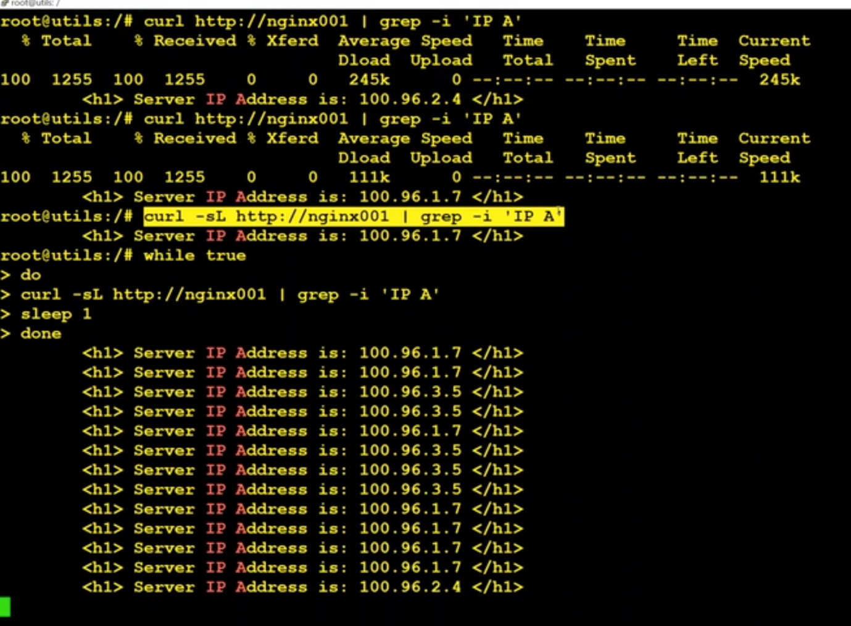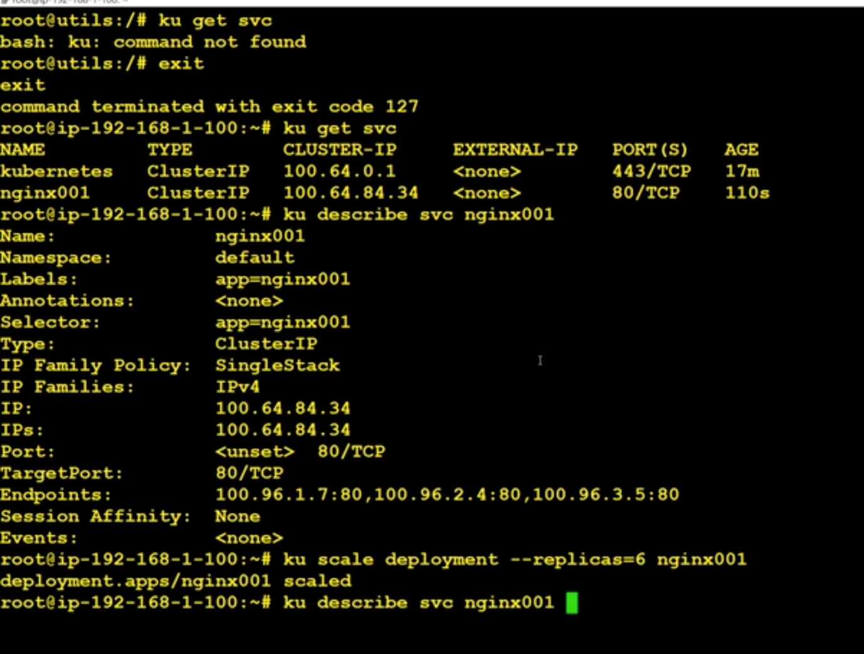

We can scale replicas of a deployments like above.

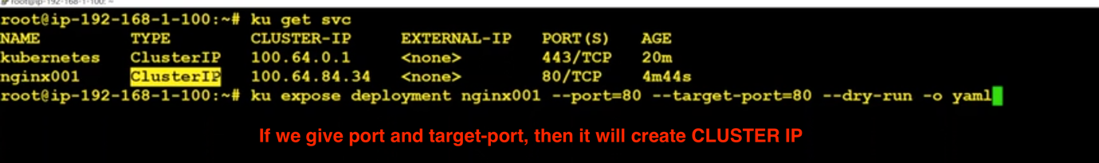

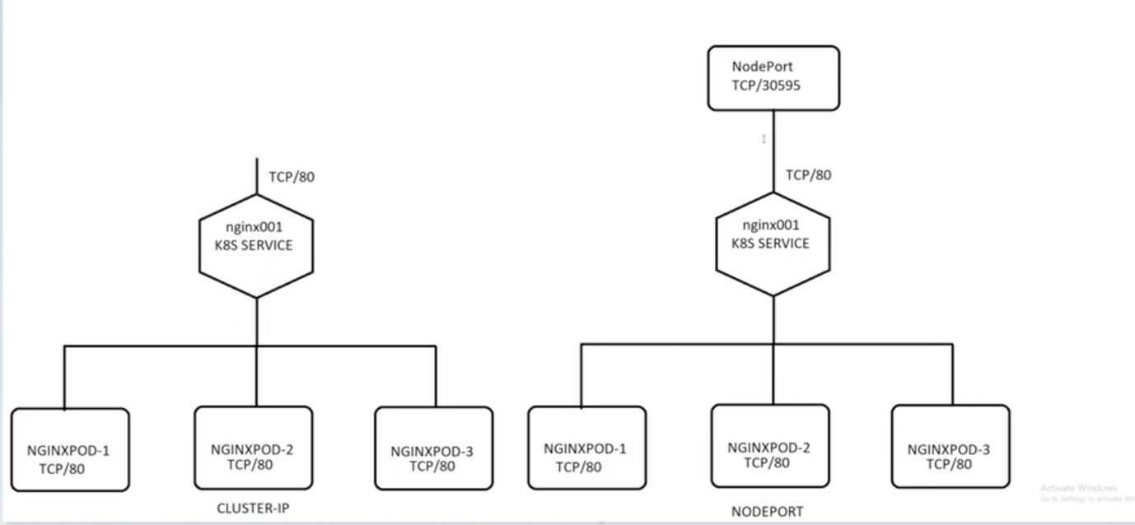

To connect to this deployment from outside. We should expose this deployment.

Creating a deployment using NodePort:

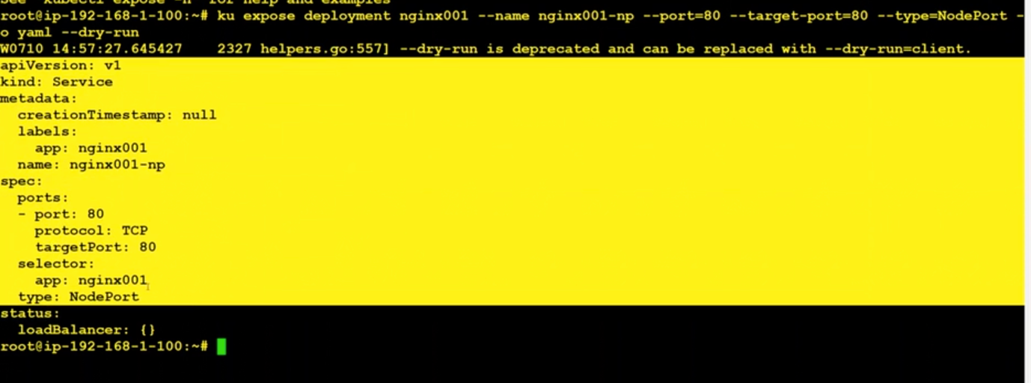

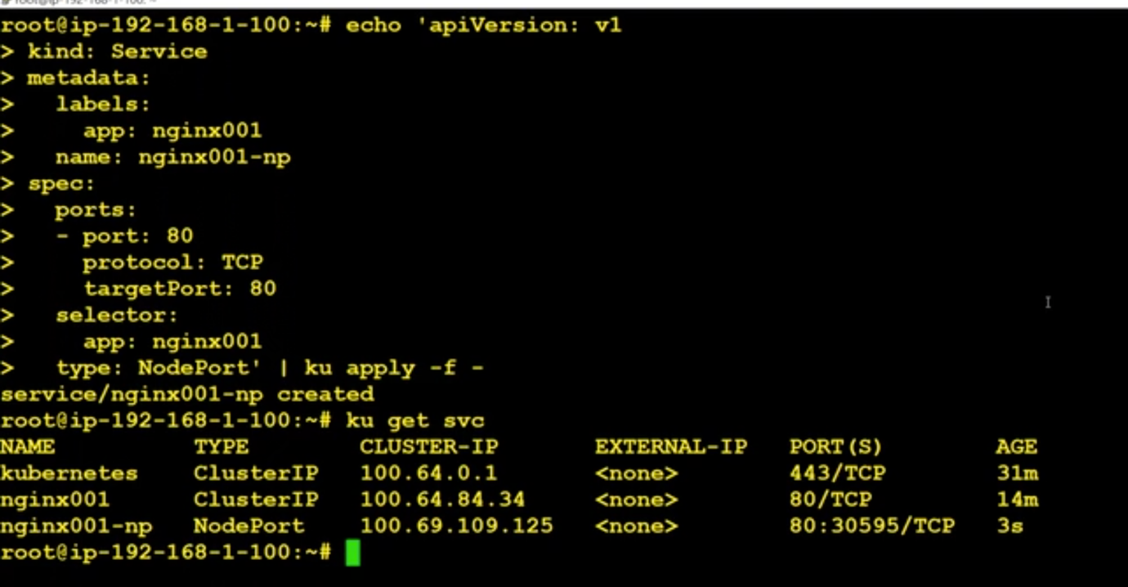

The application in exposed on port 30595. We have to open that port to make communication with it.

**How to delete a service ?**

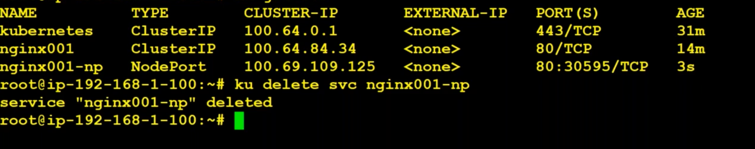

**We can directly give nodePort in yaml file with our desired ephemeral ports like this :**

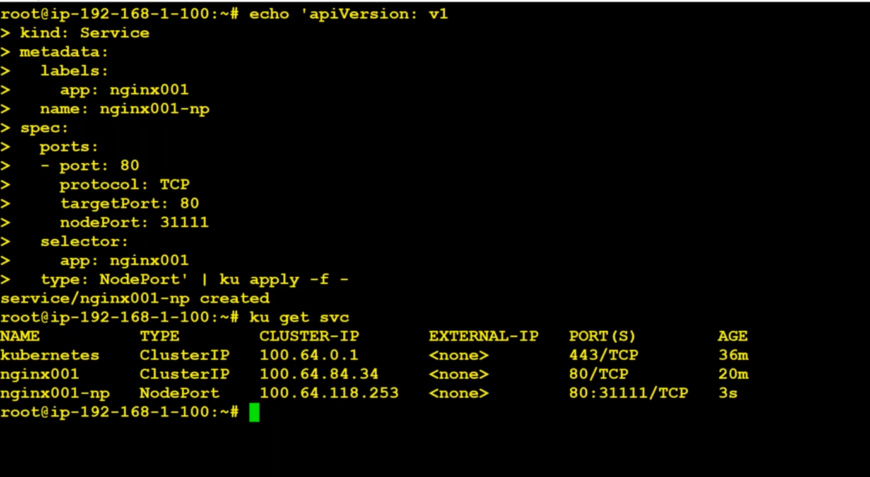

**Creating a LoadBalancer :**

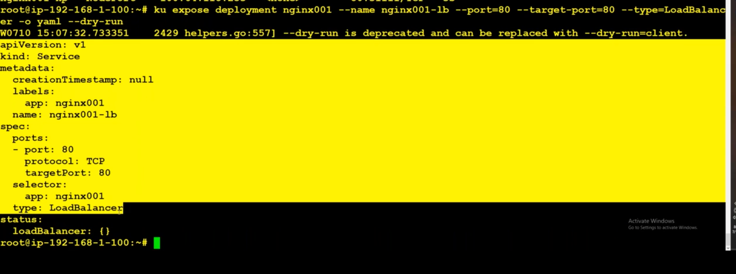

It automatically deploys classic load balancer. But we should go with network load balancer. So make use of annotations and change it.

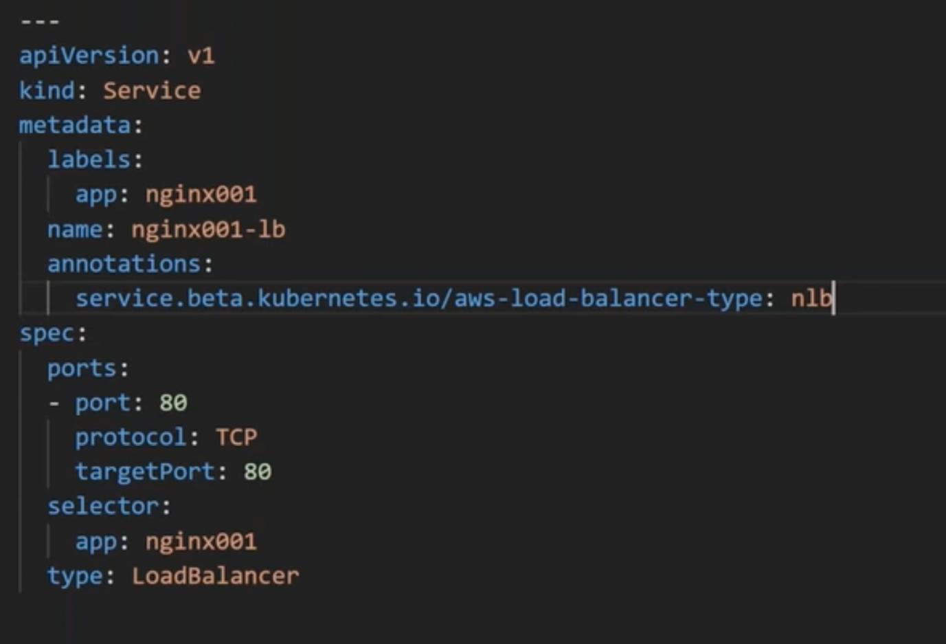

apiVersion: v1

kind: Service

metadata:

creationTimestamp: null

labels:

app: nginx001

name: nginx001-lb

annotations:

service.beta.kubernetes.io/aws-load-balancer-type: nlb

spec:

ports:

- port: 80

protocol: TCP

targetPort: 80

selector:

app: nginx001

type: LoadBalancer

Not worked for me so I gave added IAM policies like AdministratorAccess and EKSFullAccess for both master and workers --🡪 Not Recomended

Then load balancer got created



Check in Amazon :

By default target group has been created:

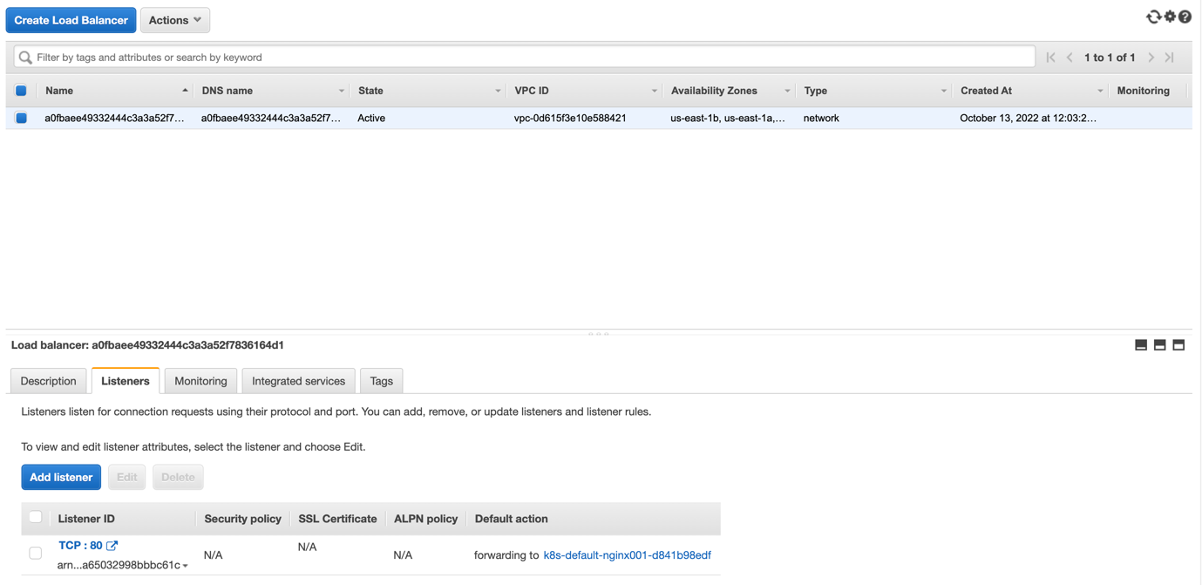

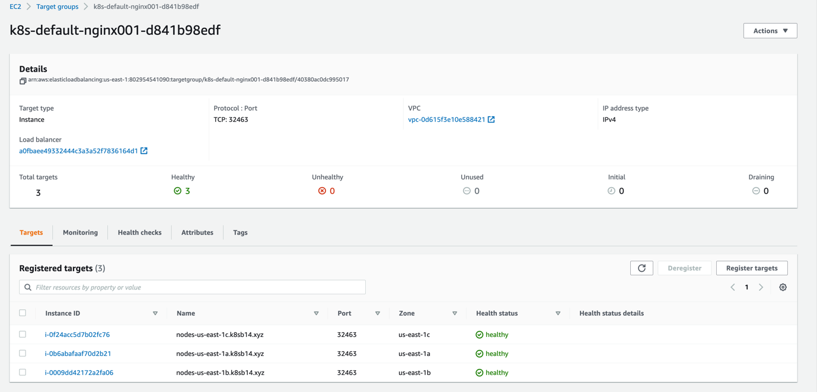

Go to Route53 and create a record for this:

Select simple routing. Then define a simple record.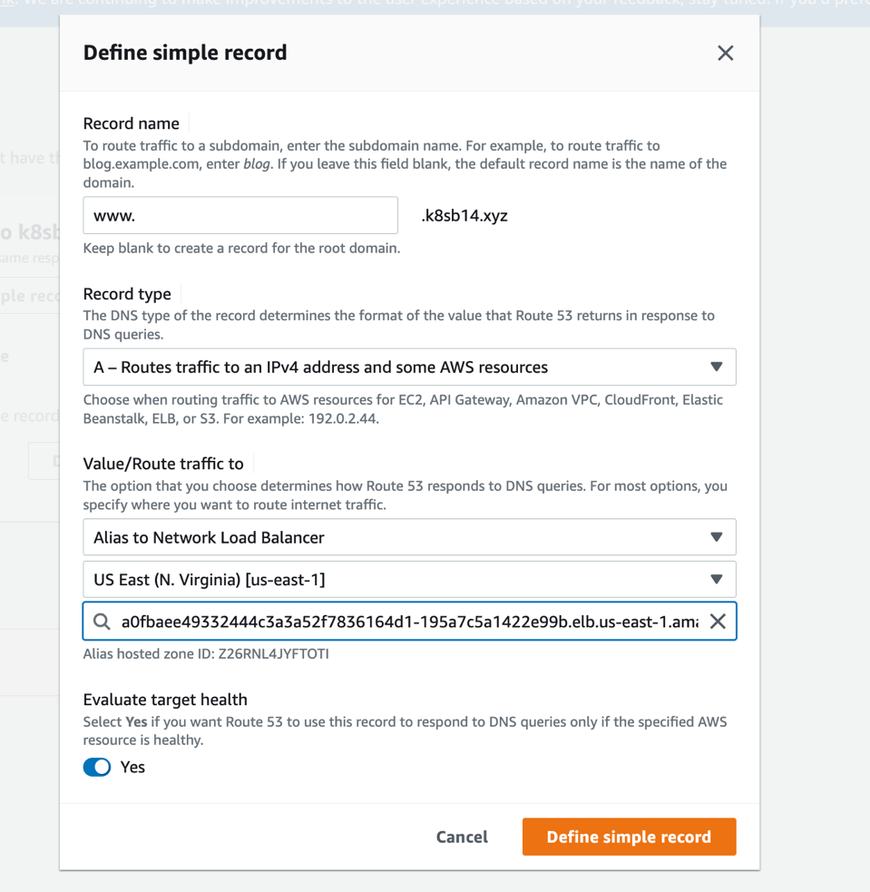

After creating a record, we have to check whether dns name has been updated ot not in google dig.

In google dig, we can give this url and select any, then we have to see the results.

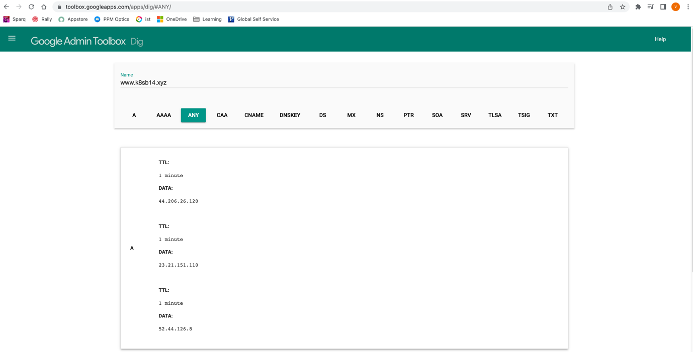

Give this url in [www.k8sb14.xyz](http://www.k8sb14.xyz). This will show the page.

We can check in this way also:

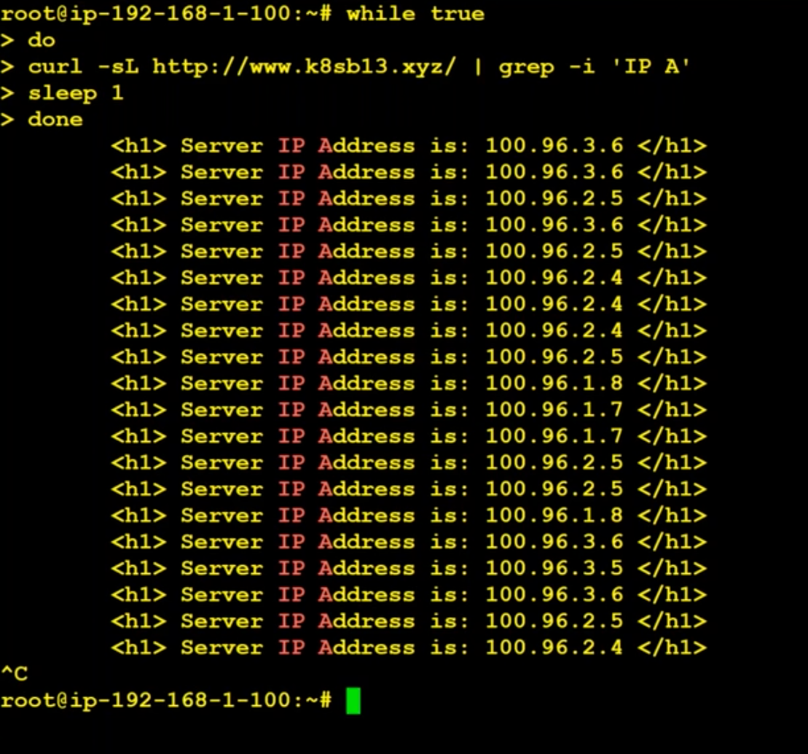

Problem:

We can only create one load balancer per deployment.

We can not create single load balancer for multiple deployments directly, but we can do it using Ingress controller.

If we take one load balancer per deployment, if we have 100 deployments, we have to take 100 load balancers. It is cost effective to use load balancers.

For suppose, if we have 100 deployments, it is not good way of approach to create 100 load balancers and sometimes we have restrictions of creating load balancers per region.

How to rescale the replicas of a deployment :

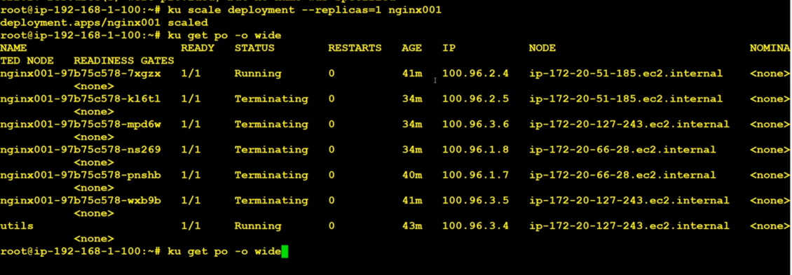

Ingress Controller and Ingress Resource:

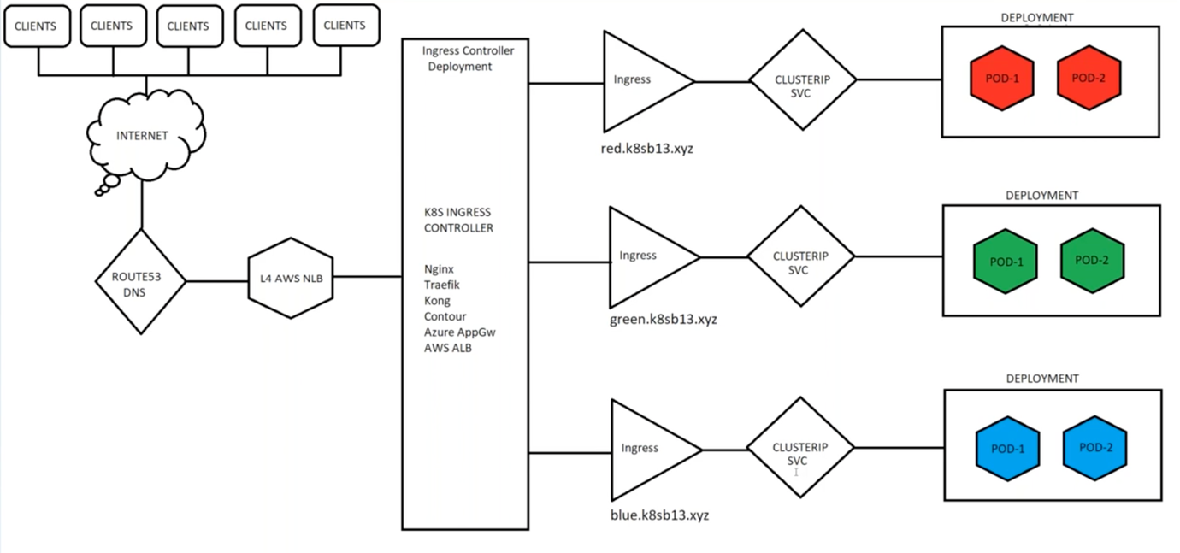

By using ingress controller, we can make http into https.

To generate certificate, use commands like :

sudo snap install --classic certbot

cd /snap/bin/

cp certbot /usr/local/bin/

./certbot -h

./certbot certonly --manual --preferred-challenges=dns –email varunreddi97@gmail.com \

--server https://acme-v02.api.letsencrypt.org/directory --agree-tos -d *.k8sb14.xyz

It will ask us to confirm the owner by creating a text record

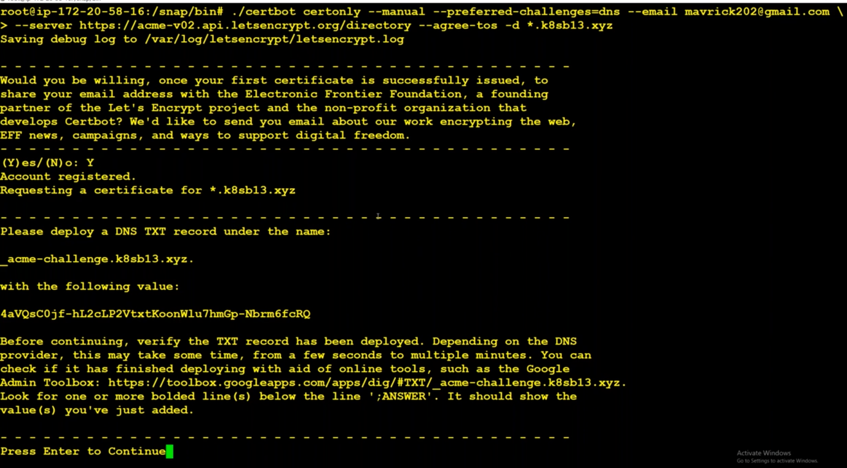

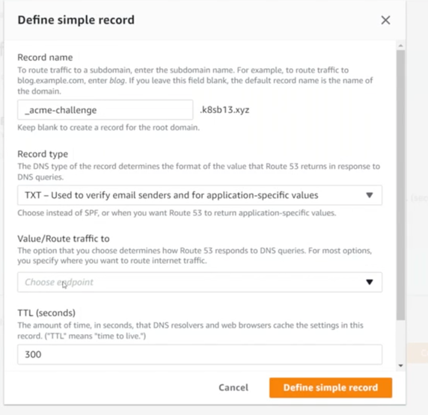

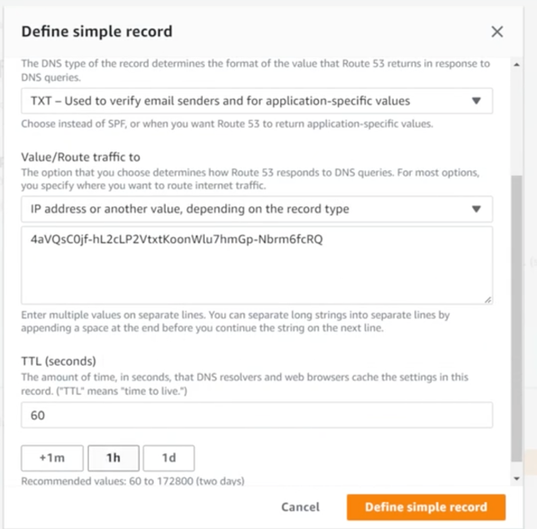

Check whether the record is up or not in google dig, by giving

|  |
| --- |
| _acme-challenge.k8sb14.xyz |
|  |

Certificate is saved at: /etc/letsencrypt/live/k8sb14.xyz/fullchain.pem

Key is saved at: /etc/letsencrypt/live/k8sb14.xyz/privkey.pem

Copy the context of privkey and paste in the tls.key file of management server root directory.

Copy the context of fullchain and paste in the tls.crt file of management server root directory.

We have to create a secrete out of .key and .crt files using command

Kubectl create secret tls nginx-tls-default --key=”tls.key” --cert=”tls.crt”

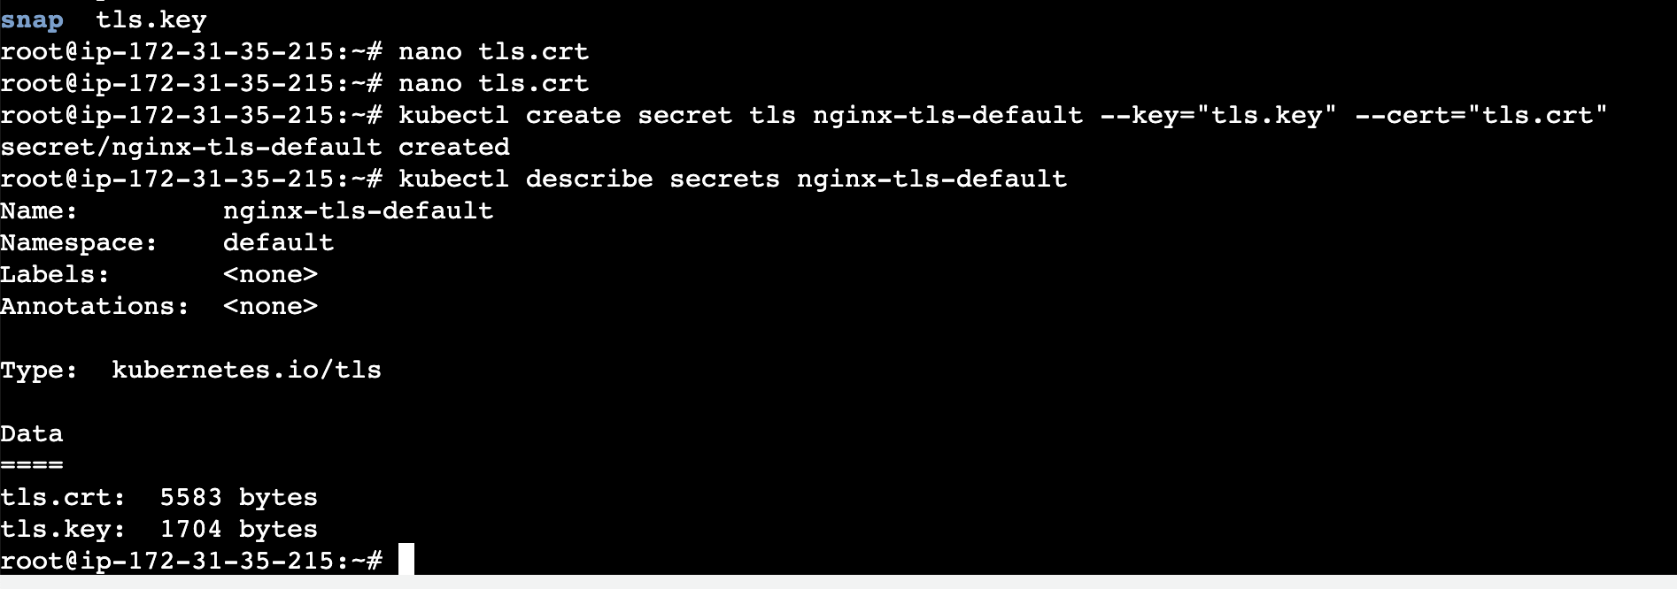

Ingress Controller can be in any namespace. But the Ingress Resource must be in the same Namespace where the application is deployed.

Create red, green, blue deployment :

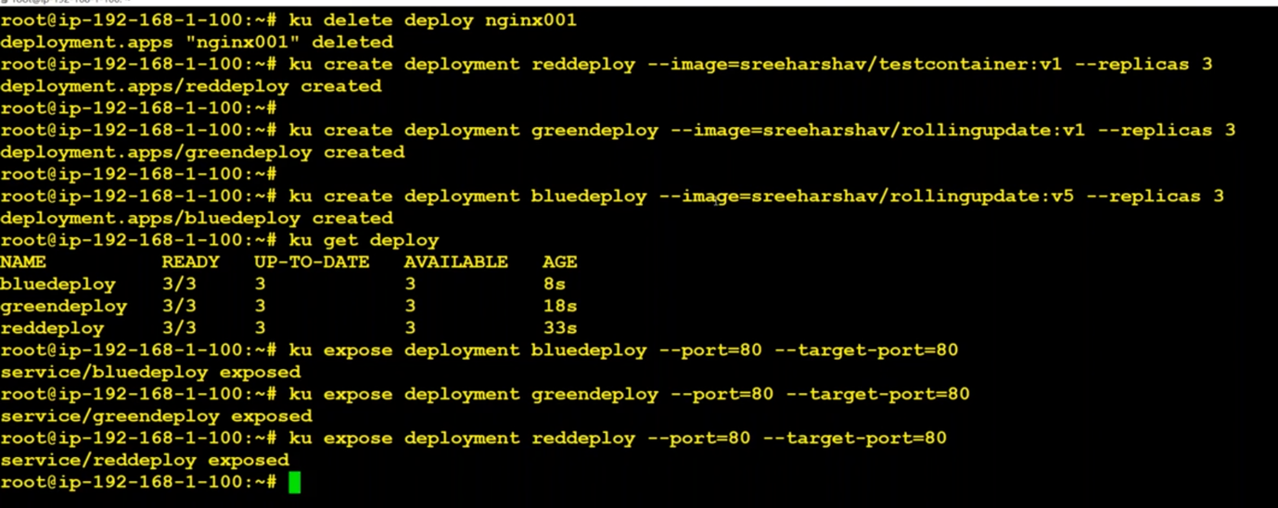

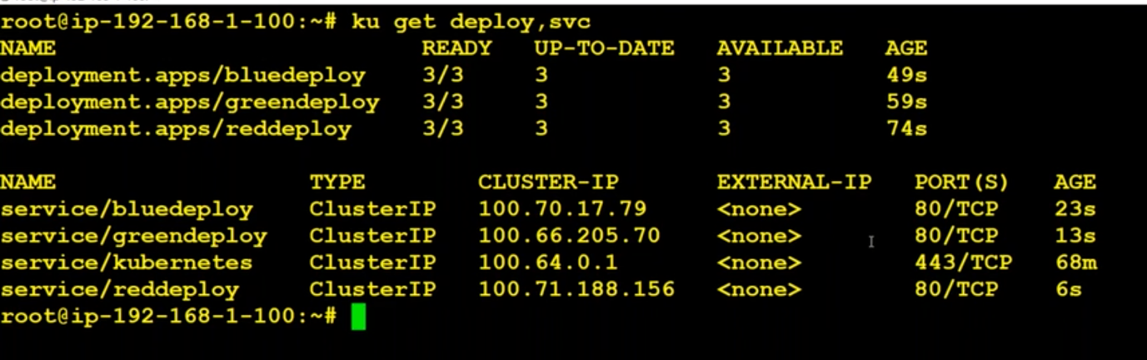

Kubectl apply -f https://raw.githubusercontent.com/kubernetes/ingress-nginx/controller-v1.2.0/deploy/static/provider/aws/deploy.yaml

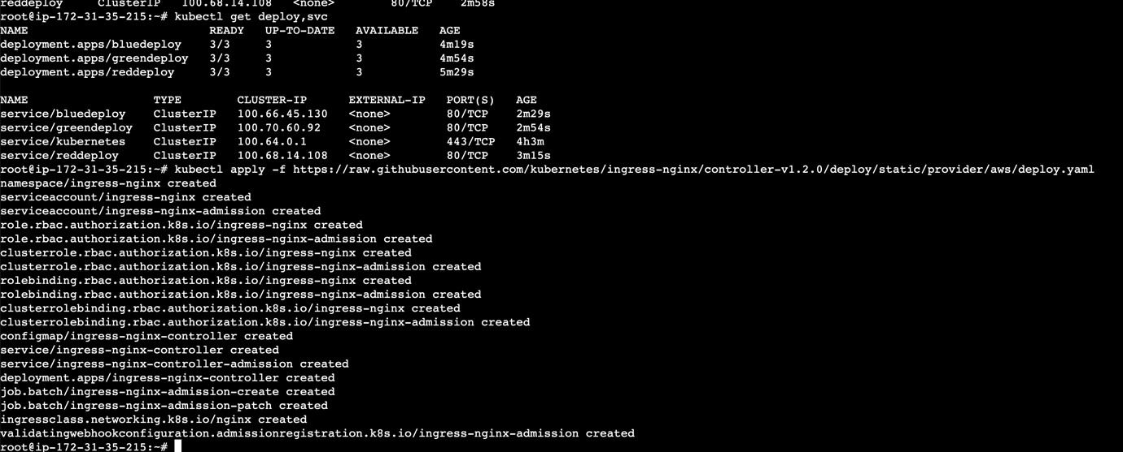

After giving that command to create ingress, it automatically creates a ingress namespace.

We can check it using command

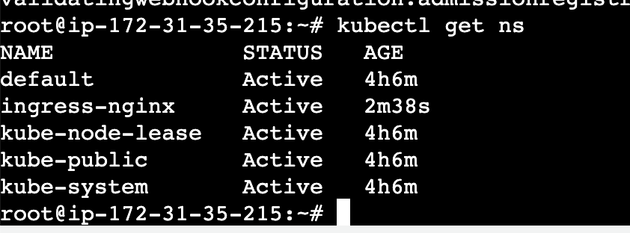

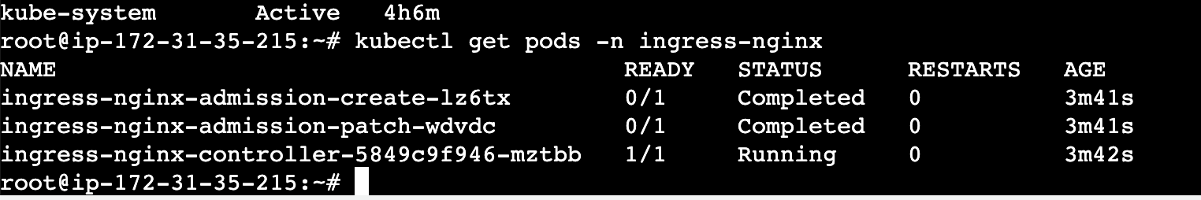

If we see above pic, ingress controller is running and it automatically creates a network load balancer.

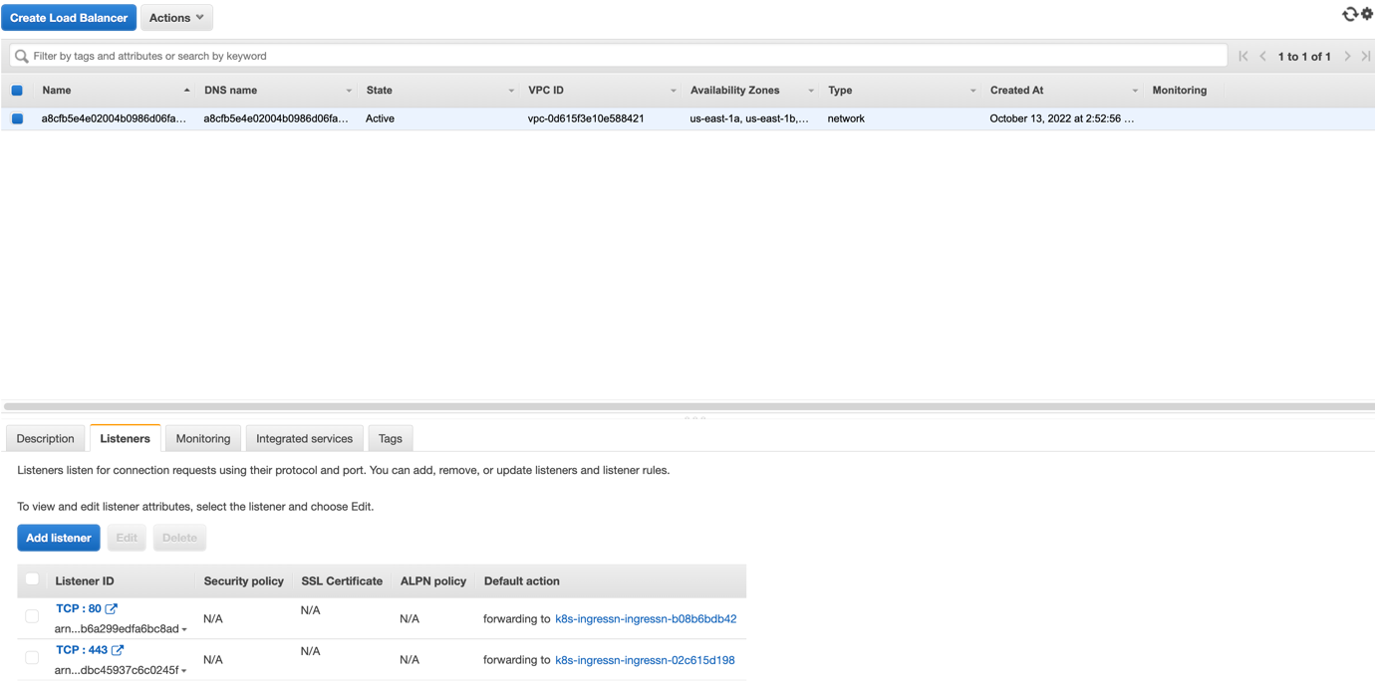

Add three records(red, green blue) in route53 for this load balancer,

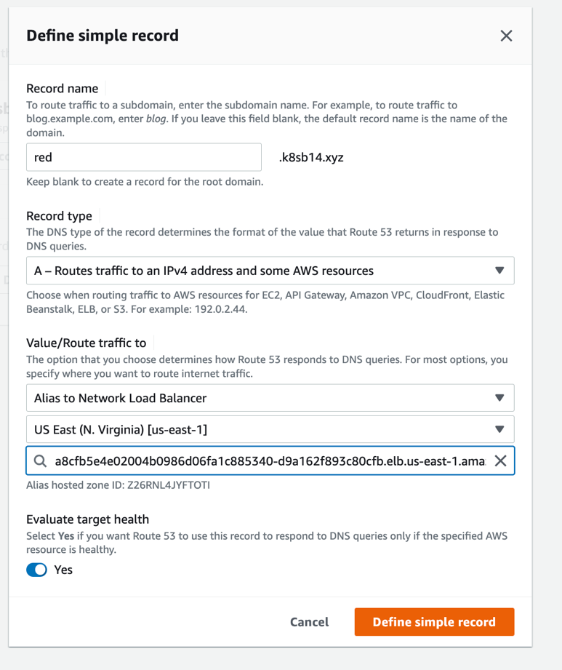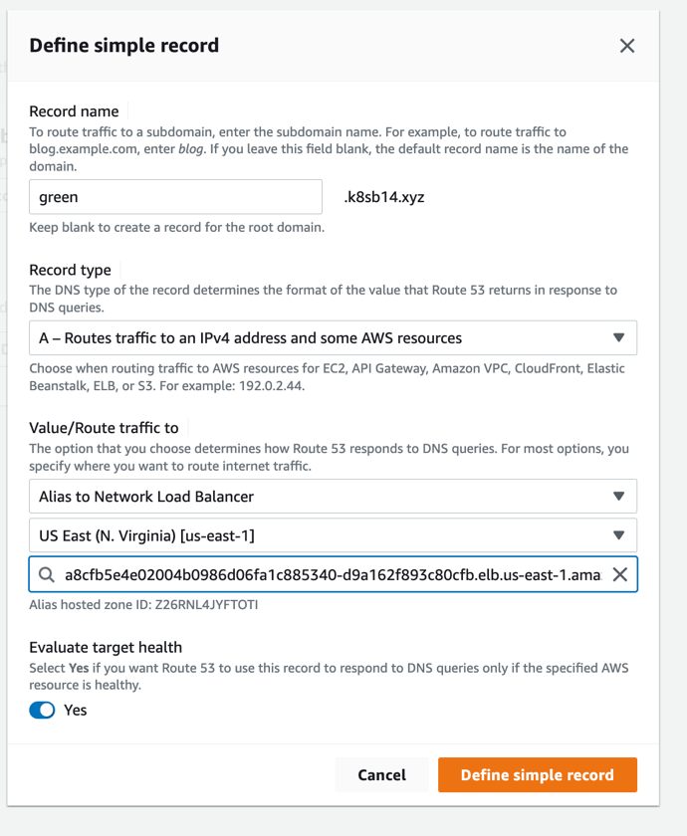

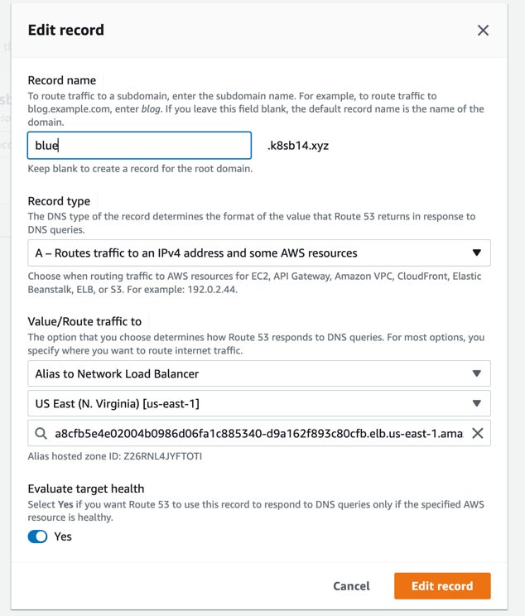

Create Ingress Service using certificate:

Nothing is there in ingress before creating Ingress services:

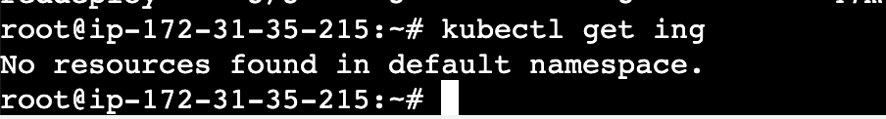

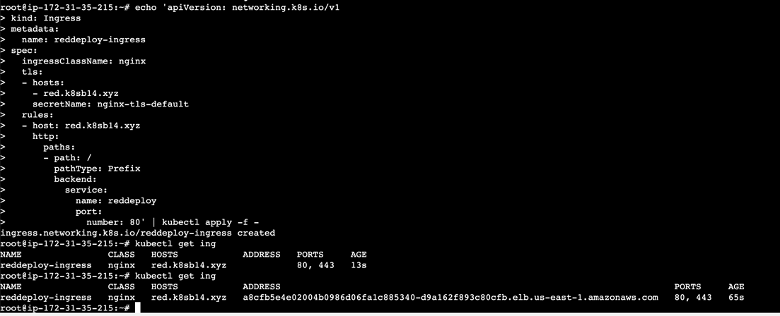

Here in address column we can able to see load balancer name.

We can use one ingress controller for multiple domains, but there might be a chance for ssl certification would not work.

Ingress controller is a pod that runs and contains the all the ingress services information.

ClusterIP vs Headless IP:

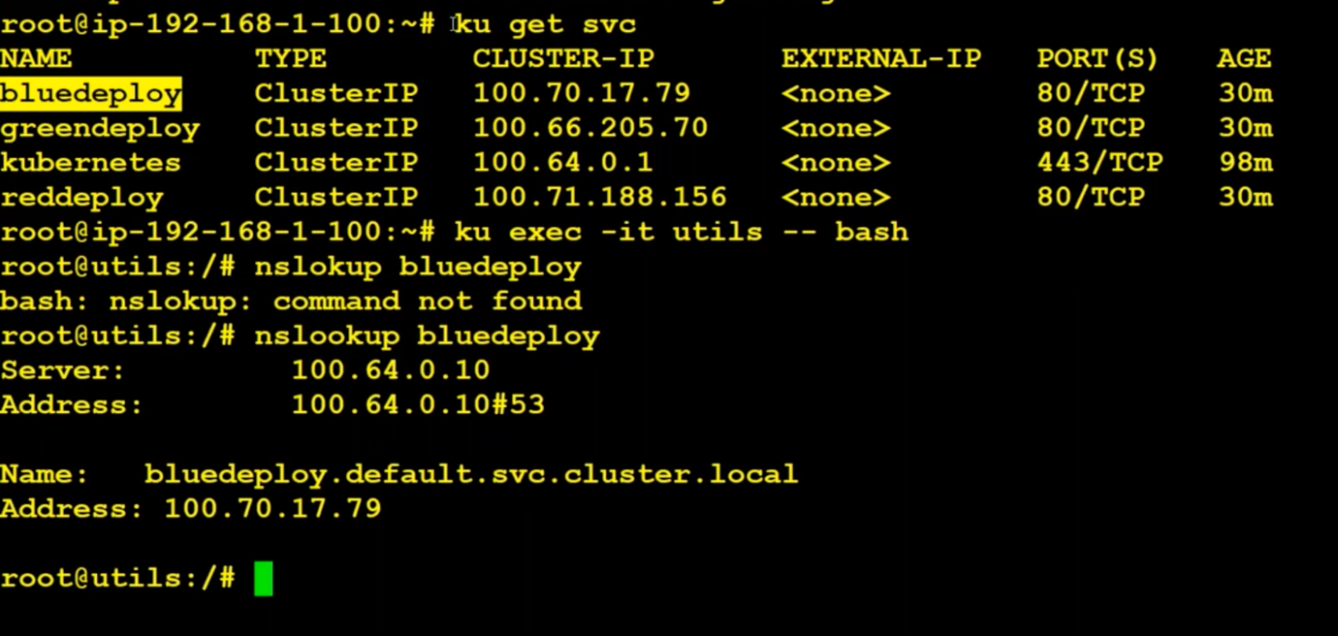

If we say nslookup inside the pod, it will go back and give the service ip(cluster ip).

If we want ips of nodes running in that service, we can use headlessIP.

Create a deployment :

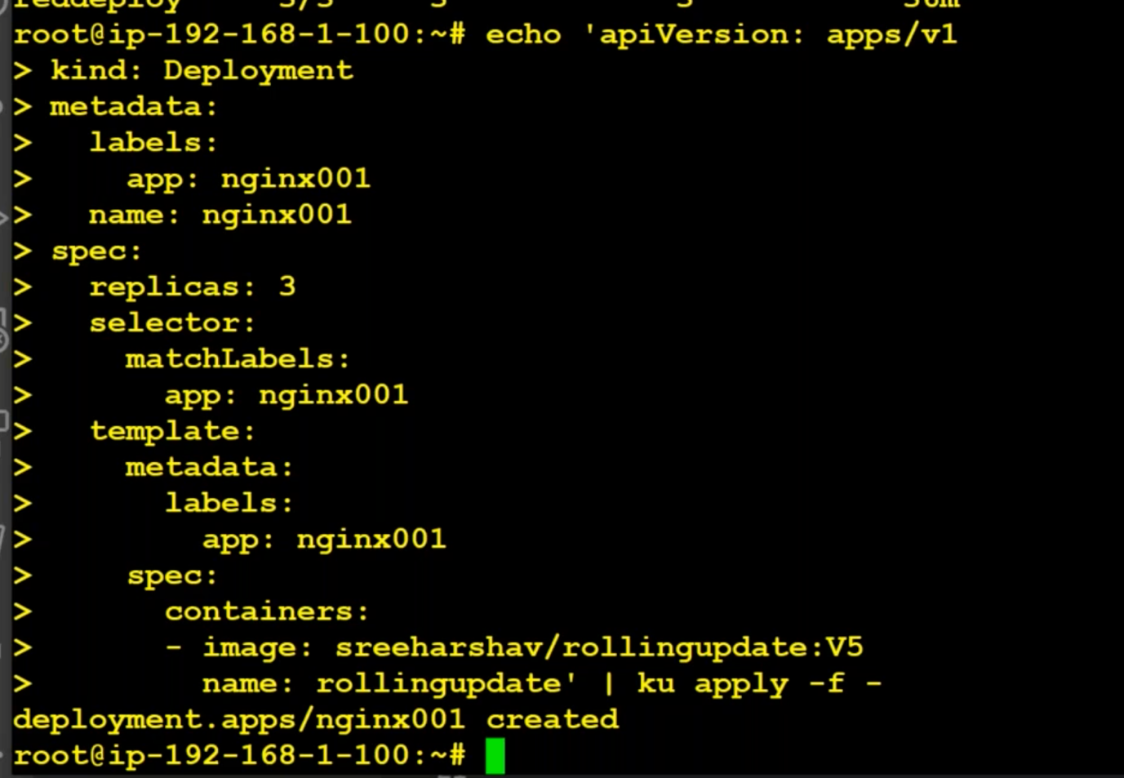

Edit/modify deployment from :V5 to :v5 by using

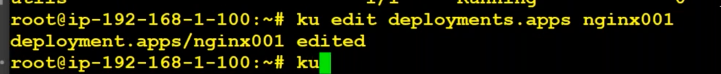

Create headless IP:

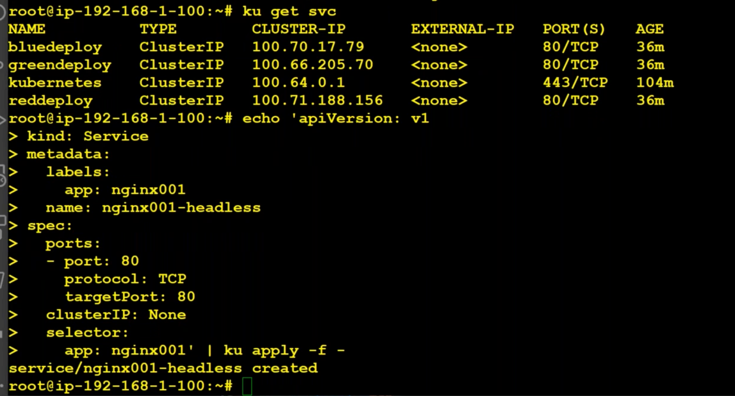

Create a normal service:

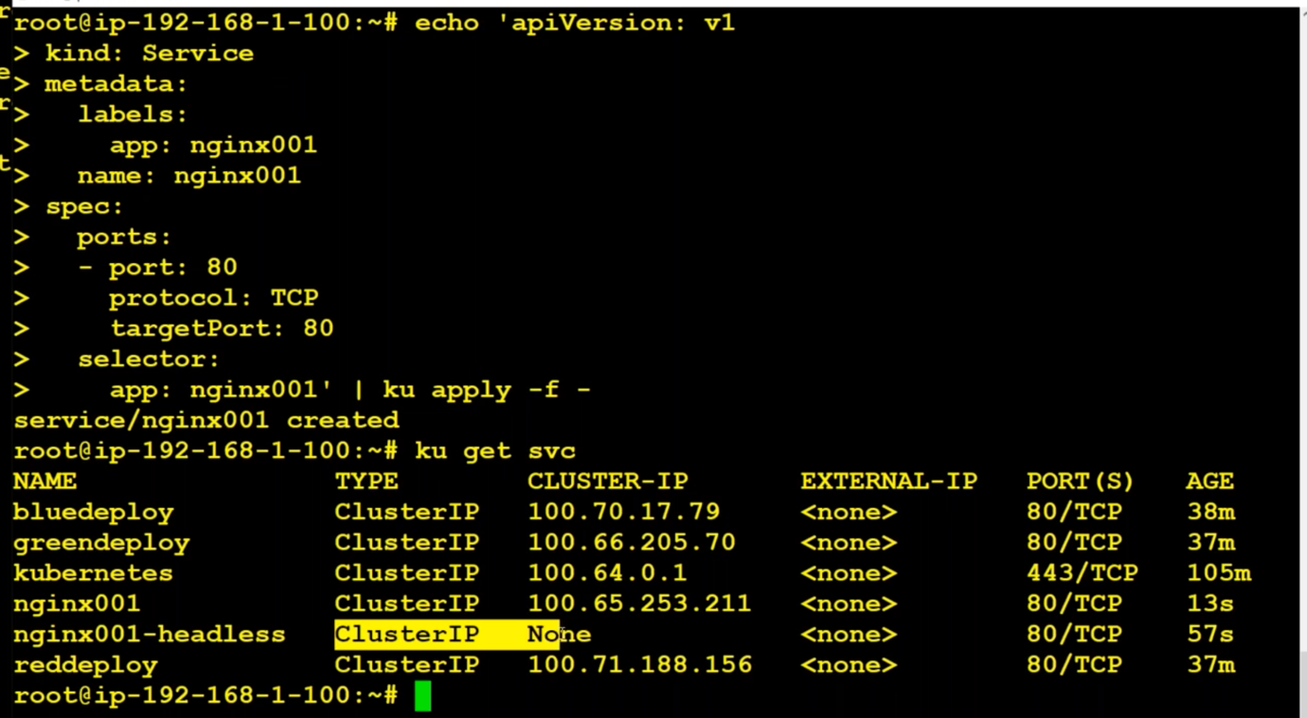

Go into the utils using :

* Kubectl -it exec utils -- bash

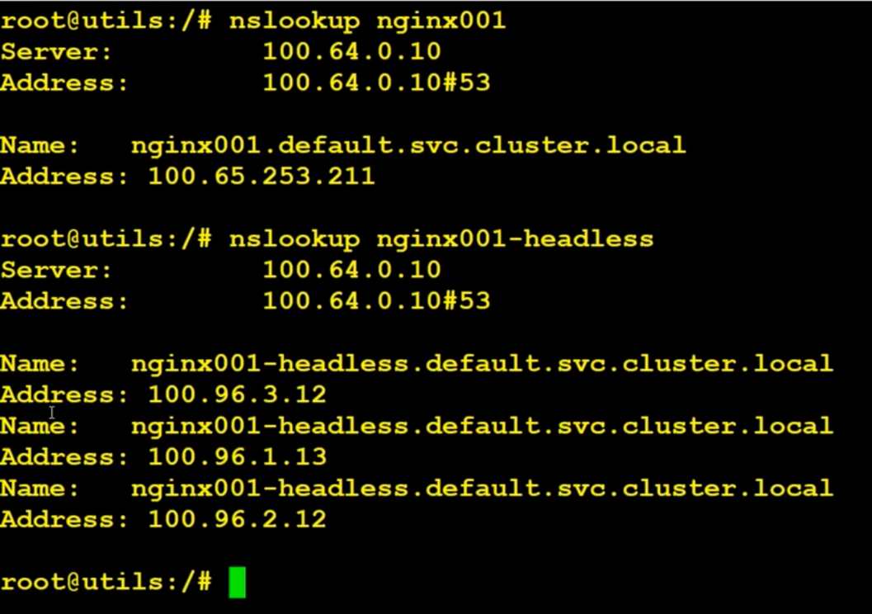

What is a headless service?

Headless Service is we need to give the clusterIP : none. It will basically create a headless service. The difference between a normal clusterIP and headless service is when we nslook up a normal service, we will get a load balancing ip(cluster IP). But when we do nslook up headless service, it will give you all the pods support by that service. This is required for statefull set and load balancers.

While deleting cluster :

First we have to remove ingress controller using

kubectl delete -f <github link>

External Ips :

Externalizing the node of a service :

**How to connect to a Cluster through Lens(GUI) ?**

Video – 6 – 1:47:00

*Kalyan reddy eks udemy:*